EXPERIMENT – 2
QUESTION
Execute and display the results for the following commands in Kali Linux Operating Systems:
- less command
- more command
- vi command
AIM
To execute and display the results of the less, more, and vi commands in Kali Linux Operating System.

1. less Command
Command:
echo -e "Kali Linux\nOperating System\nLinux Commands\nExperiment 2" > sample.txt
less sample.txt
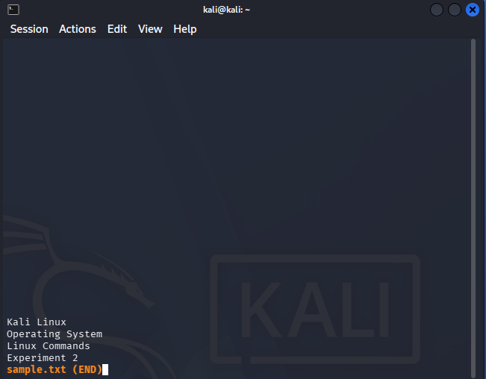
2. more Command
Type:
more sample.txt
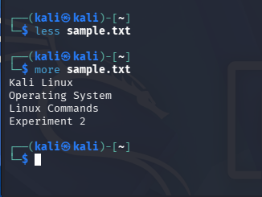

3. vi Command
Type:
vi sample.txt

